Higgins, C. (in press). Earning capital in Hawai‘i’s linguistic landscape. In R. Tupas (Ed.) Unequal Englishes across multilingual spaces. New York: Palgrave Macmillan.

1. Introduction

In its traditional formulation, the sociolinguistic concept of diglossia (Ferguson, 1959; Fishman, 1967) takes inequality as a starting point. In multilingual societies described as diglossic, ‘vernacular,’ non-official language varieties are relegated to informal, private, and usually low prestige contexts while official languages, often the legacies of colonial rule, are reserved for formal and public contexts which by their very nature index high prestige. Language in Hawai‘i is said to demonstrate this type of diglossia, where English is a co-official state language along with Hawaiian, and where Pidgin (also known as Hawai‘i Creole) is more or less only deemed appropriate for low prestige contexts (Marlow & Giles, 2010; Reinecke, 1969; Romaine, 1999; Sato, 1991). The English specific to Hawai‘i is generally not stigmatized even though Local people recognize that there are differences between mainland U.S. and Hawai‘i varieties of the language. On the other hand, Local people often take pains to distinguish between ‘proper English’ and Pidgin, often referring to the latter as a form of ‘broken English.’ Of course, Pidgin arguably carries covert prestige (Labov, 1966), for speaking this language is a crucial way to mark oneself as Local amongst a population made up of short-term visitors, transplants from the mainland United States, immigrants, and other recent arrivals. Recently, Pidgin has become more visible in Hawai‘i’s public sphere, however, which may be both a result of the expression of its value and a catalyst for increasing its value in the future. In this chapter, I argue that beyond representing mere covert prestige, this unequal language is potentially undergoing a prestige shift since it is now being used to buy and sell in the marketplace and to take a political stance, and this has implications for its symbolic –and even economic— value.

As Blommaert (2005, p. 411) explains, “inequality has to do with modes of language use, not with languages, and if we intend to do something about it, we need to develop an awareness that it is not necessarily the language you speak, but how you speak it, when you can speak it, and to whom that matters.” Through exploring modes of language use, this case of an ‘unequal’ language moving into new sociolinguistic domains thus sheds new light on the dynamic nature of inequality, prestige and diglossia in contexts where English is presumed to be the language of choice in ‘high’ domains. It also suggests that the assertion of Local identities is providing new and rich areas for further study of these topics.

2. Shifts in language inequality in Hawai‘i

In studying the modes of English and Pidgin use, it is important to acknowledge that over the course of its history, Pidgin has shifted in status from being an unremarkable lingua franca to that of an unequal language, and more recently, to a language that embodies Local style pride. In 19th century Hawai‘i, the establishment of sugar plantations led to the decline of the Hawaiian language and helped to promote the birth of a Hawaiian based pidgin that later developed into Hawai‘i Pidgin English (Sato, 1993). HPE was used as a link language among the primarily Hawaiian, Japanese, Chinese, Portuguese, and English speaking populations on plantations and in port areas. Until the turn of the century, HPE was an instrumental language used for communicative purposes. Of course, social class was certainly relevant in people’s lives, but there was a great deal of segregation between plantation workers and wealthy, land-owning Caucasians and aristocratic Hawaiians. The latter sent their children to expensive private schools while plantation workers’ children attended missionary schools and public schools, once they had been established. This segregated system continued under the auspices of the English Standard schools, established in 1924 to serve the increasing number of Caucasian Americans who moved to the islands after the Territory of Hawai‘i was established. Since most of the recently arrived haoles were not wealthy landowners, they could not afford the expensive private schools. Rather than sending their children to the public schools along with the children of plantation laborers, they demanded education specifically for their children (Benham & Heck, 1998). Consequently, English Standard schools were established, and admission to these schools was contingent on an oral language test. Unsurprisingly, children who spoke Pidgin or Pidgin-influenced English did not pass the test and were enrolled in public schools instead. As Romaine (1999, p. 289) writes, “By institutionalizing what was essentially racial discrimination along linguistic lines, the schools managed to keep creole speakers in their ‘place.’”
These schools created a race-based stratification system that had a direct impact on language inequality. Even though Pidgin was the norm in plantation communities, negative attitudes developed and became pervasive during the 1920s and 1930s, even among Pidgin speakers, due to the influence of English Standard schools and their concomitant ideologies which linked race, language, and social class. Public schools therefore became centers of language subordination. For example, “Better English Week” was held at one public high school in 1926 as a way to discourage students from speaking Pidgin. During the week, one of the classes held a ceremony which ‘married’ McKinley High to Good English, and another class put Pidgin on trial for “slaughtering good English with his double-edged tongue” (McKinley Yearbook, 1926). Pidgin was found guilty, of course, and it received a death sentence. A coffin marked “Pidgin English” was buried as part of the closing ceremonies of the week. Though such activities clearly sought to discourage the language at schools, Pidgin continued to be spoken among plantation workers and their families, and it developed covert prestige as a source of solidarity and Local identity. Overt prestige was attached to English due to its association with exclusion and privilege in the English Standard schools (Romaine 1999, p. 289). These schools were dismantled after World War II, but negative attitudes toward Pidgin had already become institutionalized along race and class boundaries.
In more recent decades, Pidgin has enjoyed a shift to a more positive status. The 1970s and the period of the Hawaiian Renaissance brought a great deal of attention to Local identity and created a context for people to show pride in their languages and cultures. On a grander scale, this was spurred by the Civil Rights Era. At the 1978 Constitutional Convention in Hawai‘i, the Hawaiian language became the official state language alongside English. During this time, Hawaiian cultural traditions flourished: traditional slack-key guitar became popular, the Merrie Monarch competition began as a celebration of hula, and the traditional Polynesian non-instrument sailing vessel, the Hōkūlea, made its first voyage. Support for Pidgin was also expressed at this time in plays about Hawai‘i, written by Local playwrights, and performed at Kumu Kahua Theater, a venue established to serve Local audiences, and in the Local fiction published by Bamboo Ridge Press and Bess Press, the latter of which published the very popular Pidgin to da Max, an entertaining illustrated Pidgin dictionary of sorts. A few years later, positive views toward Pidgin were reinforced when the Hawai‘i Board of Education attempted to ban Pidgin from schools in 1987. A backlash occurred as many residents voiced support for Pidgin, and the BOE revised its policy to allow Pidgin in the classroom while giving high priority to English.

While the domain of education remains a contentious one for the official inclusion of Pidgin (though see Higgins, 2010; Higgins et al., 2011), it has arguably grown in visibility and acceptability across domains over the past decade, reflecting a possible move away from restricted use into something approaching a more balanced bilingual model. Local authors Lois-Ann Yamanaka and Lee Tonouchi now write nationally-acclaimed fiction entirely in Pidgin, and a recent documentary on the language (Booth, 2009) has encouraged new discussions to take place about the role of Pidgin in today’s Hawai‘i. Moreover, though Pidgin was absent in television advertisements as recent as ten years ago, just the right touch of the language has become commonplace as a way for companies to speak to Local audiences (Hiramoto, 2011). To further explore the relationship between Pidgin, prestige, and domain, I examine how the language is used in the linguistic landscape.

3. Studying the linguistic landscape

My analysis builds on the original formulation of the linguistic landscape put forth by Landry and Bourhis (1997, p. 25), who describe the focus of such research as “the language of public road signs, advertising, billboards, street names, place names, commercial shop signs, and public signs on government buildings.” However, I take up more recent revisions of this framework (e.g., Shohamy & Gorter, 2009; Shohamy et al., 2010) as a way to explore how public space is symbolically constructed in part through language. Recent linguistic landscape work expands the scope of the landscape to include signs in public spaces, including handwritten signs, signs on moving vehicles, and even graffiti to analyze emplacement, or the process by which signs create the spaces that they are in (Scollon & Scollon, 2003). Leeman and Modan’s (2009) analysis of Chinese in Washington D.C.’s Chinatown helps to provide ways of looking at the symbolic value of language when it is emplaced in a public space, whether as a functional expression of the people who work and live in a place, or as a “symbolic design element, an ornament in the commodified landscape” (p. 359). To illustrate the latter, they provide the example of Starbucks, whose sign is translated into Chinese as a means of creating a Chinese sense of place in an increasingly gentrified (and non-Chinese populated) section of the city. Hence, language can be used to express symbolic-authentic meanings which speak to certain groups of people who identify with these languages, and it can be used to synthetically construct a sense of place and to commodify a language and/or culture. Leeman and Modan’s analysis is a good example of Habermas’s vision of the public sphere as a buffer between the state and the realm of private enterprise, and how the nature of public spaces is increasingly commercialized for corporate purposes.

In the case of Hawai‘i, both authentic and synthetic processes are found with regard to Hawai‘i English and Pidgin. Both languages are used for commodification purposes in the tourism industry, which is a major source of revenue for the state and a source of employment for many residents. In addition, the languages are often used in signage to advertise a local experience for Local consumers on restaurants and shops. However, as this chapter argues, the localness of Pidgin is also being used as a form of authenticity that is tied to politicized concerns about the local ecology. To better understand the ways that these languages are used to construct authenticity, I briefly describe the linguistic features of both languages.

3.1 Hawai‘i English and Pidgin
There is arguably a large degree of overlap among Hawai‘i English and Pidgin in terms of linguistic structures, for both languages share many phonological, prosodic, and lexical features.
This is compounded by the fact that most people who speak these languages mix them with regularlity, and often describe any utterance with a local characteristic to be “Pidgin,” Hawai‘i English is largely characterized by its phonological and lexical systems, which contrast with varieties of mainland U.S. varieties. Words that were historically borrowed from Hawaiian such as keiki (‘child/children), ohana (‘family’) and kama‘aina (‘resident’) are commonly understood and used without translation in print advertising and in news broadcasts. Hawai‘i English is distinct from mainland varieties in that reduced vowels are atypical (e.g., today would be produced with two full vowels, rather than a schwa), and because of the monophthongal nature of the vowels (and particularly /o/), which are often dipthongized in mainland varieties (Drager, 2012).

Major differences are found in the linguistic systems of Hawai‘i English and Pidgin. Basilectal Pidgin has seven monopthongs, whereas Hawai‘i English has 15 vowels (Sakoda & Siegel 2003). The consonant systems are also quite distinct. In Pidgin, /t/ and /d/ are heard in words like ting (‘thing’) and dat (‘that’), where /θ/ and /ð/ would be found in Hawai‘i English (Sato, 1993). Hawai‘i English demonstrates variation in post-vocalic [r], and Pidgin is typically non-rhotic in post-vocalic position. A major prosodic feature that is common to both languages is the use of rising-falling intonation in questions in sentence-final position, a feature which makes it challenging for newcomers to know if the speaker is asking a question or making a statement.

Lexical and syntactic differences have also been described for the two languages. Due to its plantation roots, lexical items from Japanese, Portuguese, Cantonese, and Hawaiian are common in Pidgin, and they are also frequently used in Hawai‘i English. A good example is pau, a Hawaiian-origin word meaning ‘finished or completed.’ This word is often heard in Pidgin imperatives such as Pau the stuffs (‘finish the work’) and in Hawai‘i English, as in Are you pau? (‘are you finished?’). While the grammar of Hawai‘i English is similar to mainland U.S. varieties, Pidgin grammar differs in many significant ways, including the use of inversion for predicate adjectives (e.g., cute da baby), the use of copula stei (e.g., da stew stei nice ‘the stew is nice/tasty’), past tense marker wen (e.g., I wen go, ‘I went’), and neva as a past tense negative marker (e.g., We neva eat dere ‘we didn’t eat there’) (Drager, 2012; Sakoda & Siegel, 2003).

4. Hawai‘i English in the linguistic landscape

Public signs carry a functional purpose to a readership that can appreciate the linguistic code, and in doing so, they can convey a sense of the local. Hawaiian-origin words are particularly common in Hawai‘i English conversation and on public signage, as illustrated in Figure 1, a sign written for bus passengers who need to know where the bus stop has been relocated to during road construction. While words such as makai (‘ocean side’) were once considered borrowings, it is more accurate to treat these as part of the Hawai‘i English lexical system in the present day. Upon encountering the sign in Figure 1, Local people would understand that 200’ MAIKAI 24/7 means that the bus stop has been relocated 200 feet towards the ocean, and is relevant 24 hours a day, 7 days a week. Across the Hawaiian islands, north-south-east-west directionals are rarely used in favor of more obvious markers such as the ocean and the mountains (mauka). All Local people know these terms, derived from Hawaiian, and newcomers quickly learn them in order to navigate their way.
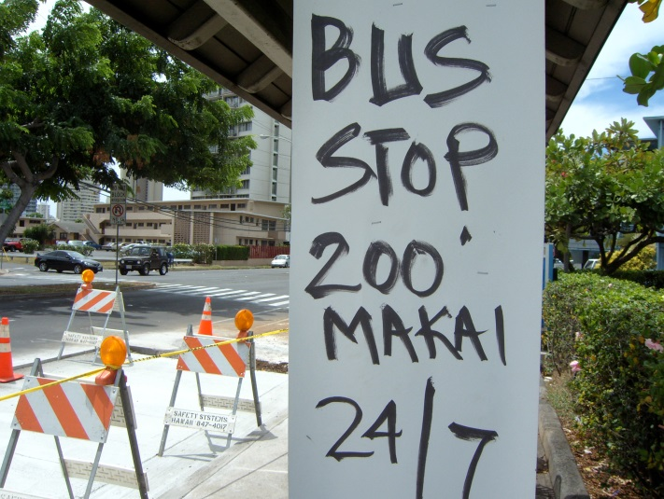
Figure 1. Bus stop 200’ makai. Reproduced with permission
of Toshiaki Furukawa.

As Figure 1 shows, the distinct lexicon of Hawai‘i English on public signage is not part of any sort of commodification or with any recognizable symbolism. Other similar and very functional signs include one found in a women’s restroom in a bar in Chinatown, which is reproduced below in Figure 2.

PLEASE DO NOT FLUSH HAND TOWELS OR FEMININE PRODUCTS!

MAHALO

USE THIS TRASH BIN FOR DISPOSAL OF DA KINES.

Figure 2. Sign posted in a restroom.

The sign uses regionally unmarked English on the first two lines, followed by the ubiquitous use of the Hawaiian word for thank you, MAHALO. This word is even more widely used than makai, and it is deeply integrated into the English and Pidgin that Local people speak across the islands. On the bottom line, customers are entreated to use a specific trash bin in English to place DA KINES (‘whatchamacallits’) a non-specific Pidgin word that here is used as a euphemism for feminine products such as tampons. The use of this word allows the sign to be discreet yet clear to patrons who know the language. The co-presence of the English phrase FEMININE PRODUCTS at the top of the sign ensures that everyone will understand the sign, including tourists and other newcomers.

Other locally-produced signs circulated for general populations make use of similar forms of bilingualism, where Hawai‘i English operates alongside mainland U.S. forms, as depicted in Figure 3. Here, KEIKI MENU (‘children’s menu’) is made more transparent through mention of what a kid’s meal includes in small print below the heading, and through the image of a personified mug on the menu, a picture that might entertain children. Of note is the use of KEIKI MENU (rather than KEIKI’S MENU), which reflects the distinct way of using uninflected determiners as adjectives (particularly on Hawaiian lexical items) where mainland U.S. varieties would use possessive forms (Sakoda & Siegel, 2003).

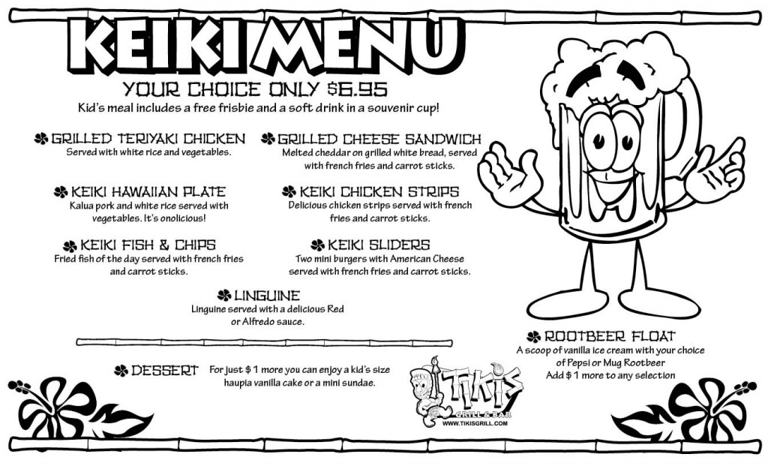
Figure 3. Keiki menu. Reproduced with permission of Bill Tobin.

A final example of the unmarked nature of Hawai‘i English comes from a less public place, albeit one that is visible to many residents of Hawai‘i. Figure 4 is an image of a label on a drawer in a patient room in a health clinic which holds medical supplies. Though the label for STERILE GLOVES is no different from what might be found on the mainland U.S., the label for STERILE PUKA SHEET is clearly Hawai‘i English, and refers to a sheet made of paper with a puka (‘hole’ < Hawaiian) in it. The sheet is to be draped over patients for privacy while they are undergoing physical exams. That the plural form appears as SHEET, rather than SHEETS, is another aspect of Hawai‘i English, and can be said to be an influence of Pidgin.

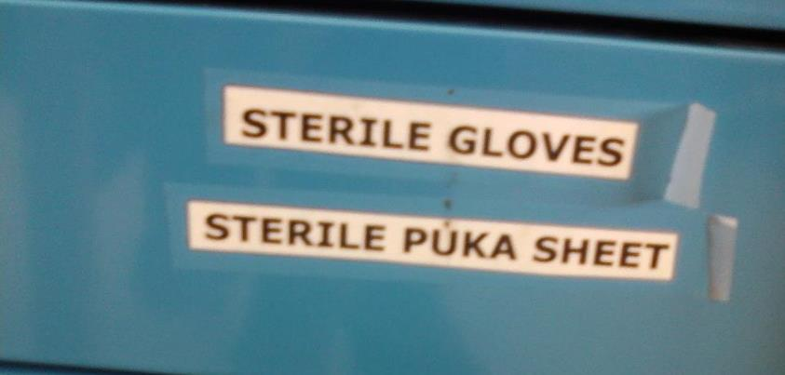
Figure 4. Sterile puka sheet. Reproduced with permission of Marissa Hanada.

5. Using the voice of the people to promote the local

The four examples above demonstrate how Hawai‘i English is used in a functional and instrumental nature, rather than any commodified sense. This makes sense since English is an official and widely used language in the state of Hawai‘i. The distinct features of the language, such as its lexicon, are simply part of the variety and readers are expected to know them. Additional examples follow:

- Truck concourse, trucks only, pedestrians kapu (‘forbidden,’ Hawaiian) – sign posted at delivery entrance of a shopping mall
- Here’s to pau hana (‘the end of work,’ ‘happy hour,’ Pidgin ) – on a Bacardi delivery truck
- Please kokua (‘help,’ Hawaiian), area beyond this sign closed to vehicles … Please help native species by walking from here – sign posted in a sand dune restoration area

The frequent use of Hawai‘i English with no expressed concern for mutual intelligbility with users of other varieties of English arguably displays a sense that the English used in Hawai‘i is simply “English.” There is no acknowledgment of its uniqueness, despite being frequently challenging for newcomers to understand.

On the other hand, in public signage containing Pidgin, much clearer forms of symbolism are found, and more direct linkages between language and Local identity are displayed. While many of these signs link language and identity to consumerism, thereby commodifying Pidgin, another set of signs tie Pidgin and Local identity to more civic-minded pursuits. Pidgin is also used this way, but when advertising local businesses and local products, Pidgin plays a more significant role in creating a symbolic economy, which Zukin (1995, p. 3) defines as “the intertwining of cultural symbols and entrepreneurial capital” (cited in Leeman & Modan, 2009, p. 337), and for creating consumer culture built around local language symbolism. Beyond entrepreneurialism, Pidgin is also used to draw attention to social justice and civic issues as a way of forefronting Local people’s concerns and issues.

5.1 Pidgin as local commodity

The first example of the linkage between language, identity, and consumerism is a sign posted in the garden section at Honolulu’s Home Depot, a U.S.-based warehouse-style home improvement store with hundreds of stores nationwide. The ad uses Hawai‘i’s state flag to introduce Carex, a plant it describes at the top as a NATIVE HAWAIIAN PLANT, which, along with the state flag, draws attention to its endemic nature. The sign was one of several also described as native Hawaiian. The purpose seemed to be to draw customers who were interested in using native materials in their own gardening projects as part of a larger commitment to addressing constant threats from outside species to Hawai‘i’s ecosystem. Dedication to ‘keeping things local’ is reflected in the DESCRIPTION & CARE of the plant, is entirely in Pidgin, and is presented as though the plant is actually speaking to the prospective buyer. The plant calls the customer, Ho cuz, try check me out! (‘Hey friend, please check me out!’), and then lists its qualities. Grammatical elements such as the copular use of stay (most likely derived from Portuguese ‘estar’) in I stay one supah gorgeous clumping grass (‘I am a really gorgeous clumping grass’) and infinitive marker fo in only need small kine water fo’ grow (‘[the plant] only needs a small amount of water to grow’) convey an authentic form of Pidgin. Beyond grammar and vocabulary, phonological features are marked, such as wit’ (‘with’) and tick (‘thick’), which authenticates the ‘voice’ of the sign.

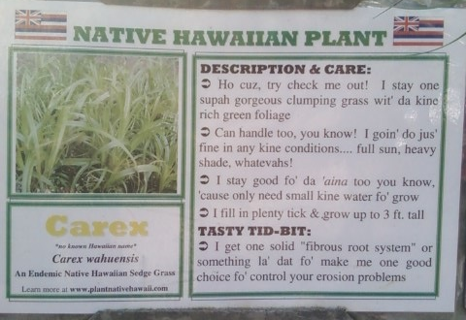
Figure 5. Carex for sale at Home Depot. Photo by Christina Higgins.

Local languages are often seen in advertisements that bring more global brands such as Home Depot to Local audiences. In the vein of McDonaldization (Ritzer, 1993), ads that draw on local language do so to appeal to Local consumers, and the Carex example is no exception. However, beyond merely establishing rapport with a Local consumer base, the ad in Figure 5 effectively links language with the delicate issue of land protection and consumers who seek to fend off invasive species. This theme continues below, to varying degrees, and seems to be a way of establishing indexing Local concerns and identities in the symbolic economy of Hawai‘i.

A Local consumer identity is also constructed on Aloha Maid Iced Tea and Calamansi (half and half) drink cans by way of the slogan HAPALICIOUS, a recently coined Pidgin word that parallels another better-known Pidgin word onolicious, which is a combination of Hawaiian ono (‘delicious’) and the latter part of the English word delicious. Consumers who are Local would appreciate this new word, which replaces ono with hapa (‘half,’ often referring to ethnicity). Many Local people are themselves hapa (‘half’ < Hawaiian) and common ethnic identifications include Chinese-Hawaiian, Japanese-haole (‘anglo’), or ‘mixed plate,’ that is, a combination of five or six different ethnicities. Though the idea of being hapa is a sensitive topic in contexts such as Japan (Kamada, 2010) it is an identification often worn proudly on t-shirts and bumper stickers in Hawai‘i. Aloha Maid Natural (and rival, Hawaiian Sun) drinks are a mainstay at local gatherings, and according to their website, they are made in Hawai‘i with local ingredients such as Maui sugarcane and local tropical fruits. Moreover, MADE IN HAWAI‘I is printed at the top of the can in red letters. Similar to the Carex sign, then, Aloha Maid Natural is linking its product to Pidgin and to the act of buying local and hence, contributing to local sustainability.

The commodification of Pidgin is particularly easy to find as a means of promoting local businesses, local products, and local pastimes. Many restaurants that serve local food exploit Pidgin to draw attention to their local ownership, local customer style, and ability to deliver what Local customers want. Examples of this symbolic economy appear below, with the Pidgin features underlined:

- Spam in the A.M. Two new local grindz! (‘foods’) – a poster-sized promotion at Burger King restaurants
- Da Kine Video (‘whatchamacallit’ video) – business sign for a store renting DVDs
- Mean da chicken (‘Really tasty chicken’) – a banner advertising huli huli (spit-roasted) chicken in an outdoor market
- Verna’s – she go! (‘top notch’) – a sign hung on a restaurant named Verna’s
- Any Kine Grill- Da Place for Ono (‘any kind grill – the place for delicious’)– neon restaurant sign
- Side Street Inn – on Da Strip (‘on the strip’) – restaurant sign
- Mo Betta Bowlla (‘an improved bowler’) – the name of a business that drills and resurfaces bowling balls
- Choke smoke Hawai‘i (‘Many smoking devices’) – a business sign for a store selling tobacco products
- Can?... Noh Can! (‘Is it possible?...Noh Foods can do it’) – an ad in a parking garage promoting Noh Foods, playing off of the well known Pidgin expression If can can, if no can no can (‘Do it if you can, and if not, don’t worry’)

5.2 Pidgin as Local politics

Pidgin is also used next to English in signs concerning public civic matters that have a decidedly local stake. In this regard, Pidgin seems to be used to set boundaries, assert local perspectives, and draw attention to causes. From a diglossic point of view, the examples that follow demonstrate that Pidgin is used to convey local views on high stakes and controversial topics in ‘formal’ domains.

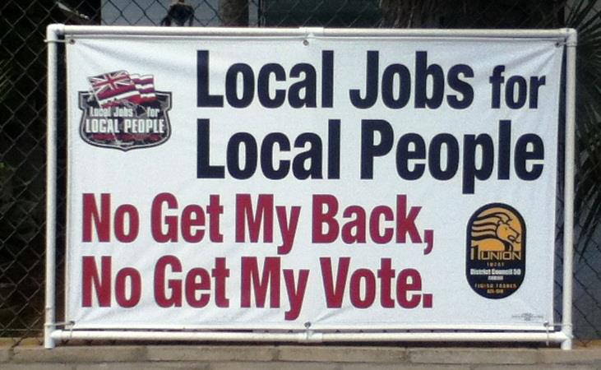
Figure 6. No get my back, no get my vote. Reproduced with permission
of Fellen Kelemente.

Figure 6 is a sign posted in Honolulu that is sponsored by District Council 50 of the International Union of Painters and Allied Trades, a labor union representing workers across North America who are in the construction and remodeling industry. Their purpose is to ensure that Local people are the ones to be offered work, rather than being undercut with cheaper labor brought in from elsewhere. In union-friendly Hawai‘i, the sign reminds politicians of the large number of unioned citizens who are about to cast their vote for mayoral candidates, the state legislature, and the U.S. congress. The sign establishes the economic-political stance clearly in English, and the repetition of Local underscores the assertion. The bottom half of the sign reads No Get My Back, No Get My Vote in Pidgin (‘if you don’t have my back, you won’t have my vote’), which is a message from DC50 to political candidates running during the 2012 year, advising them to support Local workers and labor unions. The use of Pidgin here next to a message advocating for Local people makes a strong indexicality between the language of the people and the expression of political will.

More Pidgin is creatively used on DC50’s website http://www.dc50.org/local-jobs-for-local-people/, where they encourage people to report on job sites that are hiring non-Local workers by filing a Roach Report. A roach refers to a non-Local worker who has been hired to do construction work in Hawai‘i through working for a company that has won the lowest bid. The report is promoted in Pidgin, as spoken by a Local worker. The union states,“EH, NO COCKROACH MY JOB!” (‘hey, don’t steal my job’), and the images of roaches appear next to this message, providing a negative yet effective visualization of outsiders invading the local economy. In a parallel manner as the commodity-oriented ads discussed above, the use of Pidgin along with the image of cockroaches evokes a concern about protecting Hawai‘i’s ecology, including its human workers.

The use of Pidgin to call for political action is found elsewhere as well, including bumper stickers on automobiles. One example is No be lōlō (‘don’t be crazy/stupid’), which appears as the main text on a bumper sticker for a non-profit organization (restorestreamflow.org) dedicated to stopping wasteful water diversions and restoring "the Four Great Waters" of Maui for sustainable ecology and traditional Hawaiian practices. In a similar vein are lawn signs on the Big Island which state No Spray (‘don’t spray’), asking state-controlled weed control crews not to spray herbicide on their property.

A final example is taken from a letter written by Kalani Fukumoto to the editor of the Honolulu Weekly which was written in a mixture of English and Pidgin (Figure 7). Only the first paragraph is analyzed for the sake of space, and a translation is provided to the right of the text. Pidgin features are indicated through underlining the respective elements in the English translation. This letter was written in response to deliberations by the state that took place in 2009 to use Hawai‘i’s rainy day fund to cover the budget shortfall needed to pay state workers’ salaries, including public school teachers. That year, state workers were ‘furloughed’ approximately one day a week, meaning that they did not work on that day, and they were not paid. In the letter, the writer is discussing how state workers were calling for the rainy day fund to be used instead of agreeing to furloughs. The letter points out the hypocrisy of state workers wanting to use the rainy day fund for themselves in the face of hardship, despite failing to support this idea for others, such as employees of recently defunct Aloha Airlines, who were similarly affected by challenging economic times in the past.

Original text | Translated text
Wen Aloha airlines wen down,  our government officials felt so badly,  dey stay propose free medical coverage  for all of these furloughed people,  free counseling too. Real good-hearted  officials we get. I remember all the job  fairs we had all of a sudden to get those  people back to work. Eh, but still yet,  our gvoernment (sic) officials still neva  propose to raid da “rainy day” fund for any  of these airline employees or any of the  Mahalo Airline employees that Hawaiian and  Aloha wen squash and put down. Rememba  dat? No “rainy day” fund for any of the Superferry people too. | When Aloha Airlines went down,  our government officials felt so badly,  they began to propose free medical coverage  for all of these furloughed people,  free counseling too. Real good-hearted  officials we have. I remember all the job  fairs we had all of a sudden to get those  people back to work. Yeah, but still,  our government officials still did not  propose to raid the “rainy day” fund for any  of these airline employees or any of the  Mahalo Airline employees that Hawaiian and  Aloha [airlines] squashed and put down. Remember  that? No “rainy day raid” for any of the  Superferry people, too.
Figure 7. Raining on my parade.

It is challenging to find an explanation for each and every use of Pidgin in the letter. What is more meaningful is that the letter is colored with Pidgin, and that Pidgin helps to convey the sentiment of questioning state workers’ and the state government’s actions. Similar to the examples above that provide examples of civic-minded efforts which seek to prod state officials and Local politicians into making choices that will serve the good of the people and the land, this letter speaks for a populace that is questioning the decision-making capacity of its leadership. Throughout the letter, Pidgin is threaded into the text, both at the superficial level of orthographic choices such as “Wen Aloha Airlines went down,” and in more grammatically significant ways such as “Hawaiian and Aloha wen squash.” The effect is the articulation of a Local voice that speaks for the people, and which sets up an opposition to a state bureaucracy that is difficult to trust.

6. Discussion

The data from Hawai‘i’s linguistic landscape indicate that the domain boundaries for Pidgin and English may be more flexible than previously thought. Though more research is needed to establish what is happening, it appears that a new form of diglossia may be emerging where public messages of a political nature are presented with at least some degree of a Pidgin voice. This makes sense, since these messages are coming from people who are speaking out, often in opposition to the state, or at least in opposition to the status quo. Pidgin appears to be representing a populist perspective that is demanding to be heard. A similar sentiment is attached to the more commercial acts of using Pidgin to appeal to Local consumers. When a local restaurant describes its food as broke da mout (‘delicious’), they are doing more than boasting about their tasty dishes. Beyond that, they are creating a linkage between food, place, and community. The idea of ‘keeping things local’ is alive and well in Hawai‘i, not only in terms of protecting indigenous species, but also in protecting local jobs and livelihoods. Though mass-market chain restaurants and retail outlets are becoming increasingly common across the islands, locally-owned small businesses make a strong effort to win customer loyalty and to become respected in Hawai‘i’s tight-knit island communities. Though many would describe this as simply the “aloha spirit,” going the extra mile to develop good relations with consumers is especially important in Hawai‘i since it experiences the highest cost of living in the United States while the incomes are below comparable regions on the mainland.

No matter what studies on language attitudes in Hawai‘i might indicate, Pidgin clearly has a place in Hawai‘i’s symbolic economy, as illustrated in its linguistic landscape. During this present time in which discourses of globalization, internationalization, and worldliness abound, this is a curious situation. Hawai‘i may present a case of resistance to globalizing pressures to embrace a cosmopolitan identity in pace with the rest of the world. As much linguistic landscape work shows, there is a predominance of internationally oriented cosmopolitanism that is marketed with global reference points (e.g., Kasanga, 2010; Sayer, 2010; Seargeant, 2009). This globalism is also, of course, marked through English, with some ads in countries like Germany appearing entirely in English (Piller, 2001), and elsewhere, others taking on hybrid forms to express ‘cool’ and ‘modern’ ideas to trend-observant consumers. “Youth Frenglish” often appears in advertisements in France such as “Relooker ton mobile” (‘change the look of your mobile phone’), where the English verb ‘look’ is transformed into French through the addition of affixes re- (‘again’) and –er (a verbal ending) (Martin, 2006: 183). Similar strategies have been found in Korea (Lee, 2006), Tanzania (Higgins, 2009), and Japan (Backhaus, 2007), with the effect of constructing consumers as globally-minded and sophisticated people who are interested in and familiar with the world beyond their immediate surroundings.

Since much of Hawai‘i’s linguistic landscape celebrates the local without aligning with a world beyond, the Hawai‘i context may offer us interesting foundations for further analysis of linguistic landscapes. Additional studies that explore responses to government activities through the medium of the linguistic landscape would be invaluable, and research on other multilingual contexts involving stigmatized languages would help to shed light on the nature of prestige shifts in ‘diglossic’ contexts.

References

Backhaus, P. 2007. Linguistic landscapes: Comparative study of urban multilingualism in
Tokyo. Bristol: Multilingual Matters.
Benham, M., & Heck, R. (1998). Culture and educational policy in Hawai'i: The silencing of native voices. Mahwah, NJ: Erlbaum.
Blommaert, J. 2005. Situating language rights: English and Swahili in Tanzania revisited.
Journal of Sociolinguistics 9, 390-417.
Booth, M. 2009. Pidgin: The voice of Hawai‘i. Harriman, NY: New Day Films.
Drager, K. 2012. Pidgin and Hawai‘i English: An overview. Journal of Language, Translation,
and Intercultural Communication 1, 61-73.
Ferguson, C. 1959. Diglossia. Word 15, 325–340.
Fishman, J. 1967. Bilingualism with and without diglossia; diglossia with and without
bilingualism. Journal of Social Issues 23, 29–38.

Higgins, C. 2009. English as a local language: Postcolonial identities and multilingual

practices. Bristol: Multilingual Matters.

Higgins, C. 2010. Raising critical language awareness in Hawai‘i at Da Pidgin Coup. In B.

Migge, I. Léglise, & A. Bartens (eds.), Creoles in education: A critical assessment and

comparison of existing projects (pp. 31-54). John Benjamins.

Higgins, C., Nettell, R., Furukawa, G. & Sakoda, K. 2011. Beyond contrastive analysis and

codeswitching: Student documentary filmmaking as a challenge to linguicism in Hawai‘i. Linguistics and Education 23, 49-61.
Hiramoto, M. 2011. Consuming the consumers: Semiotics of Hawai‘i Creole in advertisements.
Journal of Pidgin and Creole Languages 26, 247–275.
Kasanga, L. 2010. Streetwise English and French advertising in multilingual DR Congo:
symbolism, modernity, and cosmopolitan identity. International Journal of the Sociology
of Language 206,181–205.
Leeman, J. & Modan, G. 2009. Commodified language in Chinatown: A contextualized
approach to linguistic landscape. The Journal of Sociolinguistics 13, 333-363.

Labov, William. 1966. The social stratification of English in New York City. Cambridge, U.K.:

Cambridge University Press.
Landry, R. & Bourhis, R. Y. 1997. Linguistic landscape and ethnolinguistic vitality: An
empirical study. Journal of Language and Social Psychology 16, 23–49.
Marlow, M. & Giles, H. 2010. “We won't get ahead speaking like that! ... Journal of Multilingual
and Multicultural Development 31, 237–251.

Martin, E. 2006. Marketing identities through language: English and global imagery in French

advertising. London: Palgrave.

Piller, I. 2001. Identity constructions in multilingual advertising. Language in Society 30, 153-

186.

Reinecke, J.E. 1969. Language and dialect in Hawaii: A sociolinguistic history to 1935.

Honolulu: University of Hawaii Press.

Ritzer, G. 1993. The McDonaldization of society - An investigation into the changing character

of contemporary social life. Newbury Park, CA: Pine Forge Press.
Romaine, S. 1999. Changing attitudes to Hawai‘i Creole English: Fo’ find one good job, you gotta know how fo’ talk like one haole. In J. Rickford & S. Romaine (eds.), Creole genesis, attitudes and discourse (pp. 287-301). Amsterdam: Benjamins.

Sakoda, K., & Siegel, J. 2003. Pidgin grammar: An introduction to the creole language of

Hawaiʻi. Honolulu: Bess Press

Sato, C. J. (1991). Sociolinguistic variation and language Attitudes in Hawai‘i. In Cheshire, J.

(Ed.) English around the World: Sociolinguistic Perspectives. Cambridge: Cambridge University Press.
Sato, C. J. 1993. Language change in a creole continuum: Decreolization? In K. Hyltenstam, & A. Viberg (Eds.), Progression & regression in language: Sociocultural, neuropsychological & lingusitic perspectives (pp. 122-143). Cambridge: Cambridge University Press.
Sayer, P. 2010. Using the linguistic landscape as a pedagogical resource. ELT Journal 64, 143-
154.
Scollon, R. & Scollon, S. 2003. Discourses in place: Language in the material world. London:
Routledge.
Seargeant, P. 2010. The idea of English in Japan: Ideology and the evolution of a global
Language. Bristol: Multilingual Matters.
Shohamy, E. & Gorter, D. (eds.) 2009. Linguistic landscapes: Expanding the scenery. New
York: Routledge.
Shohamy, E. Ben-Rafael, E., & Barni, M. (eds.) (2010) Linguistic landscape in the city. Bristol:
Multilingual Matters.
Sumida, Stephen H. 1991. And the view from the shore: Literary traditions of Hawai‘i. Seattle:
University of Washington Press.
Zukin, Sharon. 1995. The Cultures of Cities. Malden, Massachusetts: Blackwell.

The capitalized term Local is used to refer to a person who is born and raised in Hawai‘i. Most Locals are descendants of sugar and pineapple plantation workers who came from China, Portugal, Japan, Okinawa, and the Philippines in the late 19th and early 20th centuries. It is generally the case that one must be born and raised in Hawai‘i to be seen as Local. Native Hawaiians may claim the identity of Local, but non-Hawaiian Locals do not refer to themselves as ‘Hawaiian.’ For a fuller discussion of these terms, see Sumida (1991: Preface).

